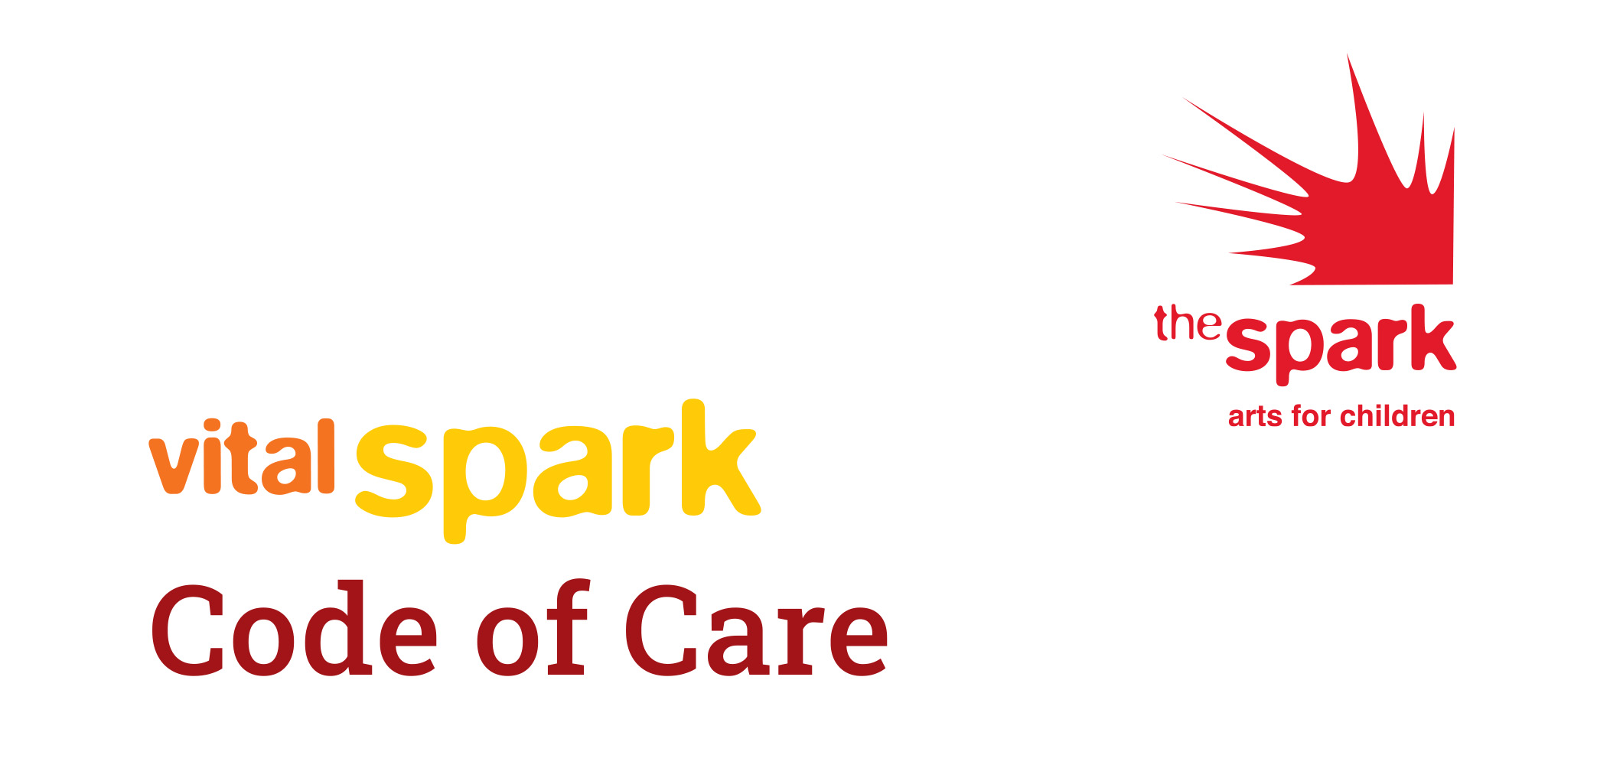
What is the Code of Care?

The Code of Care is a versatile tool kit for artists to use in whatever way this may benefit them. It is a guide and check list of sorts, to outline best practice and a chance for artists to clearly express their needs in order to do their best work. Some conversations can be daunting for freelancers. The Code of Care, is a support for artists to ensure they are being cared for and a guide for organisations to better understand the perspective of freelance working, so that together we can get on and enjoy the job and the process. The kind of support an actor might get from an agent.

Why does the Code of Care exist?

Following on from the fantastic work of the Freelance Task Force, The Spark, through the Vital Spark programme responded to artists locally, particularly in response to the #weshallnotberemoved movement, the murder of George Floyd and subsequent response from #BLM. The impact on local artists was felt and needed a space to be heard. The Spark created this (online) space in the form of A Seat at the Table. Here we discussed the daily challenges of disabled artists and ethnically diverse artists and various actions emerged. There was a clear need from artists to access support in communication with organisations. This may be an initial enquiry, at the point of contracting or in general discussion on working together. A Code of Care was born from these conversations in direct conversation with artists.
How to use A Code of Care?

The Code of Care is a live document that acts as a Pick N Mix guide for artists to use and for organisations to perhaps consider, when working with Freelancers with diverse needs. The use of this document is in full control of the artists to select the points that they feel reflect their needs and discard the elements that might be more relevant to another artist. We understand that there is not a ‘one size fits all’ or indeed terminology that all artists are comfortable with. We therefore encourage you to keep this document live, relevant and what is set out to do, a support for artists. Find your way to make The Code of Care useful to you.

Use as you see fit, this may be (though not restricted to) using it as:

- A checklist

- Support and suggestions to raising topics we may find challenging

- Fees
- Work that related to our lived experience
- How we process information
- Needs around a disability
- Sharing something about ourselves that we may feel vulnerable about
- Support to raise something when we might not feel heard

When we might use the Code of Care?

This is very much up to each individual. The Code has been designed to be flexible, there are sections for you to choose from and sections that will be irrelevant to your needs.

You may use this document in the following ways (though not restricted to):

- In an informal email
- To add something you would like reflected in a contract
- To support you in a conversation
- Simple to read and use as a guide to better understand artists you are working with

Please do feedback to let us know what you are finding useful and whether you feel something is missing, or has evolved. Talk to us, so that we can support in the best way possible. This has come from listening to you and is there to support for as long as it feels relevant to you. We are still actively listening. Email: vitalspark@thesparkarts.co.uk
Code of Care
Please copy / paste / delete to your own needs. Edit and save it in the way that works for you. This is for you to make your own.

My fees
I am an experienced arts professional, with XX years working within the sector and I value my time as such.

Below is the fee structure I currently offer to employers. This can be negotiated and is the start of a conversation.

Role | Day Rate | Hourly Rate | Half Day Rate | 5 day+ Contract daily rate
E.g Director

Travel and accommodation beyond XX mile radius of home base is charged in addition.

- Please note this is reviewed on a yearly basis and cannot be taken as an agreement until fees are stated in a signed contract.

What I need to know:
Ask all the questions you need to regarding the contract

- Is this a paid opportunity or are you asking for me to volunteer my time?

- What time in days/hours you would like to contract me? As I will need to allocate this in my diary, to ensure that I can fully plan and deliver my best work for you, alongside other freelance commitments

- What the rate of pay is that you are offering/What your budget is?

- When you will make payment and how this happens?

- Will my travel expenses be included or paid in addition?

- What is your Covid-19 safety policy and how will we together keep participants and myself safe?

- When will I receive a contract/agreement from you confirming the above?

When sharing information with me please consider:
Outline your needs and requirements

- Making information as clear as possible

- Converse with transparency

- Allow for breaks -

- in line with ITC / Equity / Law as it will allow me to refresh, refocus and deliver my best work

- In order to support my access needs I need to take breaks every XX hours

- Take time to break down the process together into manageable steps, so that we ensure we are working to the same reasonable and agreed targets

- Allow me some time to process information

- Give me ample notice- avoiding last minute changes where possible, I understand we are working in changing times, so please ask what my needs are and ensure that I am fully supported through any changes

What I need you to know about me for me to be my best:
This is a chance for you to include any individual information, which may be around but not limited to (more of a checklist for you):

- Access requirements

- Health Care requirements

- Information to be presented in a particular format to help you i.e. the use of coloured paper, large font etc

- Receiving information/a script before a meeting/reading

- Around dyslexia:
- Not too much information given all at once
- Writing to be spaced out
- use of bullet points
- Notes after meetings, even if brief, are supportive - I do take my own but may miss things whilst trying to listen and write

- I can only represent my own lived experience as a (insert as you identify) artist and cannot represent all (insert as you identify) artists

- Please understand that conversations around racism/disabilities /gender/xxxx/ can be triggering, therefore I ask you to hold this in mind when discussing in meetings or wider platforms. It may not feel like a safe space for me. Consider/Ask how you might be an ally to me in these situations

What I need from you:

- Fair and open feedback

- Around boundaries: Clarifying expectations and agreements together

- Using email to communicate unless we are having a meeting

- I prefer zoom meetings rather than phone call / phone calls to zoom / in person meetings

- If a phone call is necessary, then sending an email beforehand setting a duration required for the conversation is helpful to work around

- Allow me time to process, explore and research so I can offer you my best

- Give me opportunities to pause and reflect, this is part of my practice and allows me to respond drawing from my full range of tools

- If safe and possible I would like to take a moment to walk with you in nature to discuss the project

- Allieship - Where you choose to make people aware

- When it feels relevant to reflect back our lived experience

About Me

I bring a unique experience to all work I engage in.
(Delete or amend as suits you. We are aware there may be a preferred way you identify and this terminology in itself is a challenging and an ongoing conversation).

As a ...

- African diaspora / South, East and South East Asian diaspora
- ethnically diverse
- an artist who experience racism
- disabled
- Disabled/Deaf/Neurodivergent

…artist my lived experience shapes my work and the contribution I bring to paid roles.

Through conversation with Inc Arts and BAMEover debate, we are using the following terminology (April 2021). Please do update and talk to us on the relevance of this section.

In order to keep myself safe/to acknowledge this I may need:

- Time to reflect

- The option to take some time out to gather my thoughts

- Please be aware, some conversations I may find triggering and I would appreciate some time to reflect back to you my experience of…

Thank You

Thank you for taking the time to engage with this and I hope that this gives
rise to more joyful equality and understanding in all your collaborations.

If you found this useful please share with others and please do keep in touch, so that we can keep this document live and supportive.

If there is anything that you would like to add or comment on please email vitalspark@thesparkarts.co.uk

If you would like to pass The Code of Care on to others, please make sure you credit it as follows:

The Code of Care was created by The Spark Arts for Children in partnership with Mashi Theatre and a number of independent freelance artists.

Join the Vital Spark community and keep in touch

Website: thesparkarts.co.uk/vital-spark
Email: vitalspark@thesparkarts.co.uk
Telephone: 0116 261 6893
Follow our blog: vitalspark.blog
Facebook group: Vital Spark Artist Community

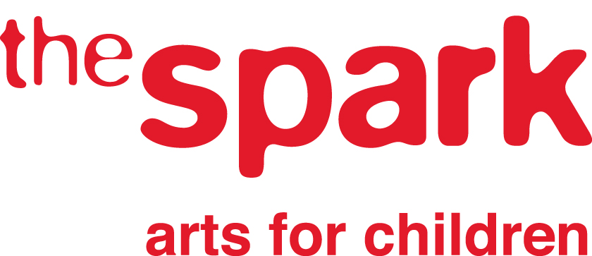
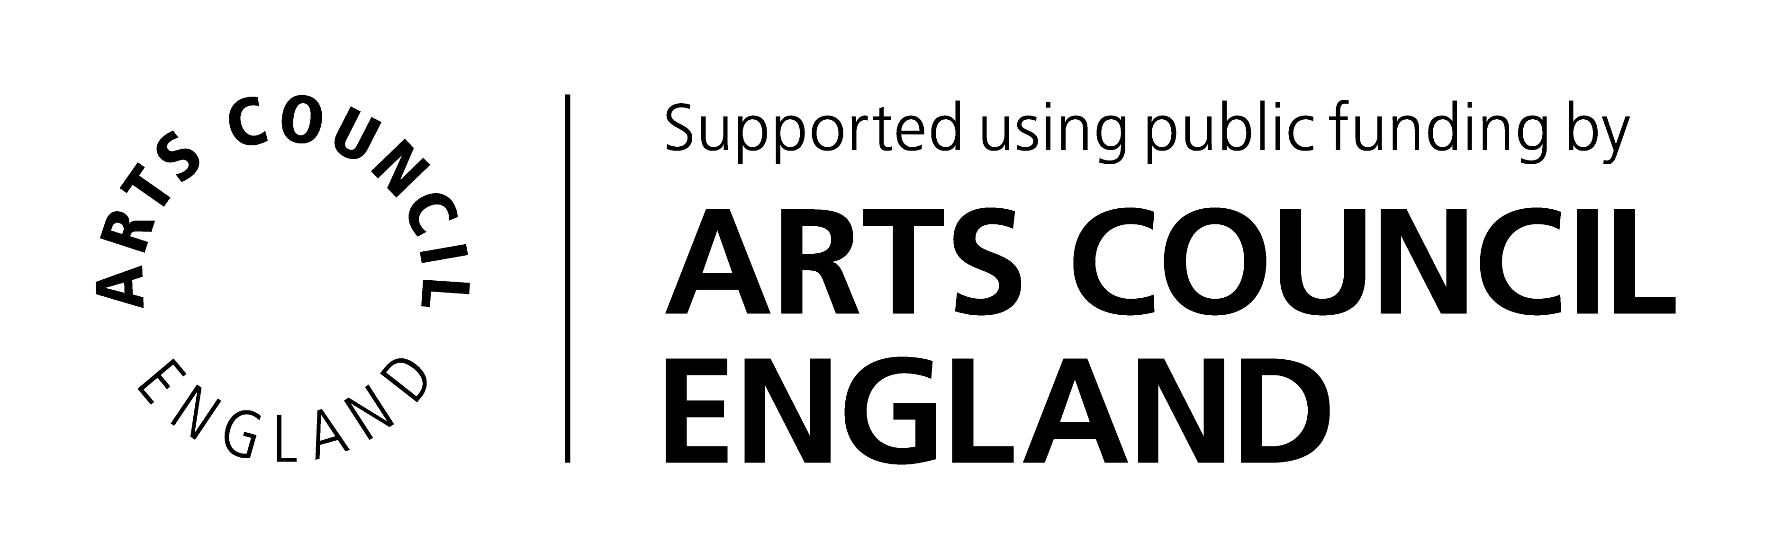

The Spark Arts for Children is a company limited by guarantee, no.5254229. Registered charity no. 1106952.

