Spark Arts for Children
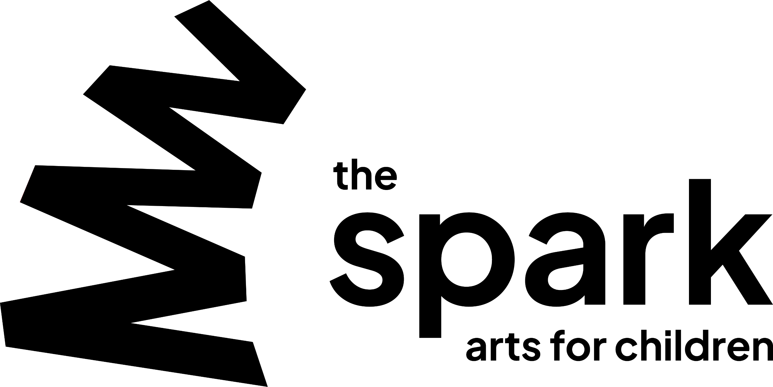
Music Champion Project 2024 – 25

Nursery Expression of Interest Form

Name of Nursery:

Contact Name:

Contact email:

Contact phone number:

- Why is your nursery interested in taking part in this project?
Please tell us about any work you are doing already to develop music and creativity and how this project could support this.

- Who would be the lead practitioner for the project?
Please include information about why the practitioner (which could be yourself!) is interested in this project and how it would help their development.

- What would you hope to gain by being part of this project? (for your children, staff and wider nursery)

- Nursery Commitment
Professional development is a key part of this project and we will require the lead practitioner to participate in training sessions, mentor meetings and reflection and planning time in between each delivery session.

The project will include:-
- Welcome meeting Thursday 7th November 4-5.30pm
- 2 induction training days in the autumn (5th&6th December)
- 2 x half day network sessions in the spring term
- 1 x half day sharing event in the summer term
- 1 x end of project symposium event.
- Reflection and planning time after each delivery session is also important to allow creative exploration and development of practice.

Can you confirm that your nursery will be able to support this professional development time?

Y/N

Please send this completed expression of interest form to hazel@thesparkarts.co.uk by 5pm - Monday 7th October 2024.
If you have any questions about the project please contact Hazel Townsend – hazel@thesparkarts.co.uk.

