Spark Takeover Event – 18th May 2025
Address: Vijay Patel Building, De Montfort University Mill Lane, Leicester LE2 7PT

Directions to the car park:
You can park at the main DMU staff carpark. The car park is off Gateway Street - please use Sat Nav/Google map postcode: LE2 7DP and look out for the “Staff and Pre-booked visitor parking” sign on your left. It is play and display if you are staying the whole day - £4. You can claim this back from Spark Arts.

We have also attached a campus map for the venue. The car park is marked 38 on the map and the building is marked 50.

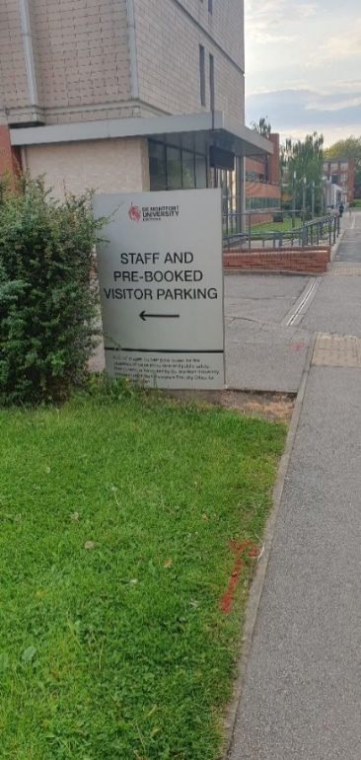

Turn left and when you get to the barrier buzz and let them know you are parking or dropping off your child for the Spark Event at the Vijay Patel Building. They will be expecting people and you can park. It is £4 for the whole day and you can claim this back from The Spark Arts.

To walk to the venue from car park:
Turn left out of the car park towards the university.
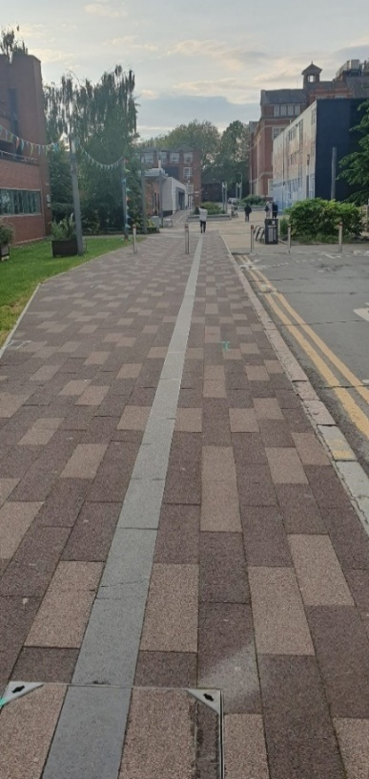
Turn left again at the pedestrian cross roads and you will see the Vijay Patel Building and gallery in the distance.



You will be greeted at the entrance by a member of the Spark team.

